System Design & Architecture

1. Define the System Architecture
Goal: Create a high-level design that meets customer needs while aligning with Cambio’s tech stack.

A. Architectural Diagram
Use C4 Model or UML to sketch:
- Context Diagram (System boundaries + external integrations).
- Container Diagram (Key services: API Gateway, FHIR Validator, Auth, etc.).
- Component Diagram (Detailed modules within each service).

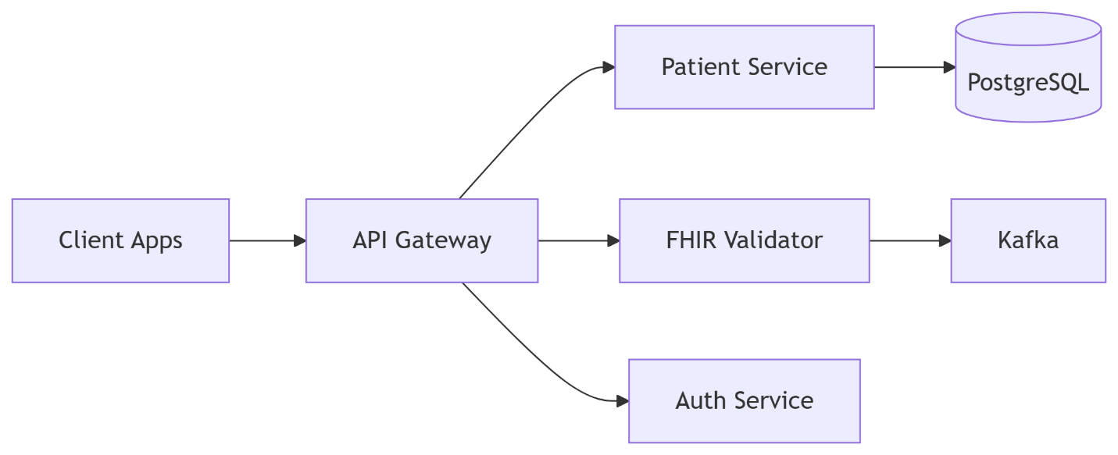

B. Technology Choices
Requirement | Technology | Justification
Scalable API Routing | Spring Cloud Gateway | Java-based, integrates with Spring Boot
FHIR Validation | HAPI FHIR | Industry standard for HL7 FHIR
Real-Time Alerts | Kafka | High-throughput event streaming
Auth | Keycloak + OAuth 2.0 | Healthcare-grade security

2. API Contract Design
Goal: Define how systems will communicate (before writing code).

A. OpenAPI/Swagger Spec
- Document endpoints (e.g., GET /fhir/Patient/{id}).
- Include:
  - Request/response formats (FHIR JSON/XML).
  - Error codes (e.g., 403 Forbidden for unauthorized access).

Example:
yaml
paths:
/fhir/Patient/{id}:
get:
summary: Get FHIR Patient
security:
- OAuth2: [patient.read]
responses:
200:
description: FHIR Patient resource
content:
application/json:
schema:
$ref: '#/components/schemas/Patient'

B. Event Schema (Kafka Topics)
Define Kafka message structures:
json
{
"event_type": "lab_result_ready",
"patient_id": "123",
"timestamp": "2023-09-20T12:00:00Z"
}

3. Database Design
Goal: Structure data for security and performance.

A. PostgreSQL Tables
Table | Purpose | Key Fields
patients | Patient demographics | id, name, birth_date, gender
access_logs | Audit trails | user_id, action, timestamp
api_clients | OAuth 2.0 clients | client_id, secret, scopes

B. Security Measures
- Row-Level Security (RLS):
sql
ALTER TABLE patients ENABLE ROW LEVEL SECURITY;
CREATE POLICY patient_access ON patients USING (id = current_user_id());
- Encryption: Use PostgreSQL pgcrypto for sensitive fields.

4. Proof of Concept (PoC)
Goal: Validate the riskiest components early.

A. Sprint 1: API Gateway + Mock FHIR
- Scaffold Spring Boot + Spring Cloud Gateway.
- Add a mock FHIR endpoint (/fhir/Patient).
- Test with curl:
bash
curl -H "Authorization: Bearer $JWT" http://localhost:8080/fhir/Patient/123

B. Sprint 2: Auth + PostgreSQL
- Integrate Keycloak for OAuth 2.0.
- Connect PostgreSQL with Spring Data JPA.

5. Plan for Iterative Development
Use Agile phases to build incrementally:
Phase | Focus | Outcome
1 | API Gateway + FHIR Mock | Basic routing + FHIR validation
2 | Auth + PostgreSQL | Secure access + data persistence
3 | Kafka + Monitoring | Real-time alerts + observability
4 | Kubernetes Deployment | Scalable production setup

Key Deliverables After This Step
✅ System Design Document (Architecture diagrams, tech choices).
✅ API Contracts (OpenAPI specs, Kafka schemas).
✅ PoC Code (Git repo with minimal working gateway + FHIR).

Core Microservices
Microservice | Responsibility | Tech Stack | Key Endpoints/Notes
API Gateway | Route requests, enforce auth/rate limits | Spring Cloud Gateway + Keycloak | /{service}/** routes, integrates with Auth Service
Auth Service | Issue/validate JWT tokens, manage roles | Keycloak + Spring Boot Adapter | /auth/realms/{realm}/protocol/openid-connect
FHIR Validator | Validate FHIR data (syntax, profiles, codes) | HAPI FHIR + Spring Boot | POST /fhir/$validate (auto-enabled in HAPI)
Patient Service | CRUD for Patient resources (FHIR ↔ DB) | Spring Boot + Hibernate + PostgreSQL | GET/POST /fhir/Patient (FHIR-compliant)
Event Service | Stream FHIR changes (Kafka topics) | Kafka + Spring Cloud Stream | Topics: fhir.patient.create, fhir.observation.update
Audit Service | Log access (who viewed/changed data) | Spring Boot + PostgreSQL | Subscribes to Kafka events from other services

Optional Services (For Extended Features)
Microservice | Responsibility | Tech Stack | Integration Notes
Billing Service | Handle payments (FHIR ChargeItem) | Spring Boot + Stripe API | Consumes fhir.chargeitem.create events
Lab Service | Manage lab results (FHIR DiagnosticReport) | Spring Boot + PostgreSQL | POST /fhir/DiagnosticReport (validates via FHIR Validator)
Notification | Send alerts (SMS/email) | Twilio/SendGrid + Spring Boot | Subscribes to Kafka alert.* topics

Key Responsibilities of EncounterService
Function | FHIR Resource | Example
Track hospital visits | Encounter | Emergency room visit, scheduled checkup
Manage patient status | Encounter.status | in-progress, finished, cancelled
Link to providers/locations | Encounter.participant | Doctor, nurse, clinic location
Record visit type | Encounter.class | inpatient, outpatient, virtual

AppointmentService
- Schedule Appointments
  - Book new appointments (in-person, virtual, or follow-ups).
  - Assign time slots based on doctor availability and patient preferences.
- Manage Appointment Lifecycle
  - Handle status changes:
    - booked → arrived → completed → cancelled.
  - Send reminders (SMS/email) before appointments.
- Coordinate Resources
  - Link appointments to:
    - Doctors (who is available?).
    - Rooms/Equipment (e.g., MRI machine slots).
- FHIR Compliance
  - Manages the FHIR Appointment resource.
  - Example fields:
json
{
"resourceType": "Appointment",
"status": "booked",
"start": "2025-09-20T10:00:00Z",
"participant": [
{ "actor": "Patient/123", "status": "accepted" },
{ "actor": "Practitioner/456", "status": "accepted" }
]
}
- Integrate with Other Services
  - Patient Service: Verify patient details.
  - Encounter Service: Convert appointments to visits upon check-in.
  - Billing Service: Trigger invoicing after completion.

ObservationService

- Store Clinical Measurements
  - Lab Results: Blood tests, urine analysis, biopsies.
  - Vital Signs: Blood pressure, heart rate, temperature, BMI.
  - Clinical Notes: Symptoms, pain levels, mental health assessments.
- FHIR Observation Resource Management
  - Handles structured data in FHIR format:
json
{
"resourceType": "Observation",
"code": { "text": "Blood Pressure" },
"valueQuantity": {
"value": 120,
"unit": "mmHg"
},
"subject": { "reference": "Patient/123" }
}
- Support Search & Filtering
  - Fetch observations by:
    - Patient ID (e.g., all labs for Patient X).
    - Test Type (e.g., only blood glucose results).
    - Date Range (e.g., vitals from the last 30 days).
- Trigger Alerts & Notifications
  - Flag abnormal results (e.g., high cholesterol → notify doctor via Kafka).
  - Integrate with CDS Hooks for clinical decision support.
- Link to Other Services
  - Patient Service: Verify patient existence before recording data.
  - DiagnosticReport Service: Group related observations into formal reports.
  - Encounter Service: Tie observations to a specific visit (e.g., ER check-up).

